Adopted (xx/xx/xxxx)

Standard Range Operating Procedure
Putnam Fish & Game
110 Stonebridge Road
Woodstock, Ct
860-928-0450

Chapter 1
Preamble
Putnam Fish and Game is a nonprofit organization that has been in existence since 1945 and has been a place for sportsman to practice their shooting and fishing skills.

Chapter 2
Range Operations
Range Operations Guide
Sections

- General
- Facilities Use
- Permitted Live fire / Shooting
- Range Limitations and Safety Requirements
- Authorized Personnel
- Personnel Responsibilities
- Hours of Operation and Use
- RSO, When required, Range operating procedures
- Use of Alcohol / Drugs (prescription, non-prescription, illegal).
- Emergency Plan (injury and medical support)
- “Hold Harmless” Agreement form

- General. Live firing at the Putnam Fish and Game indoor and outdoor ranges is intended to provide current members access to a facility where they can become familiar and proficient with their firearms.

- Facility Use. Use and availability of the indoor and outdoor range is at the discretion of the Club President and Range Chairman.
  - Guests of members are required to sign in and out on the “Guest Book”.
  - A RSO is not required for general range use by members. RSO (s) shall be required for “special events” such as turkey shoots, plate shoots, CMP events, etc. and any shooting events involving the general public.
  - New members shall not use the range until they have received the “Range Safety Briefing” and have reviewed and agreed to all range rules.
  - No tracer or incendiary ammunition is allowed or firearms deemed illegal by State or Federal laws.
  - Firearms known to be defective or damaged shall not be used at this range.
  - Alcoholic Beverages and Drugs - Because on the nature of shooting sports and potential for disastrous consequences, consumption and use of alcohol and prescription or illegal drugs, even over the counter drugs, as harmless as they may appear, can alter perception and awareness. Use of these substances will not be tolerated before and during shooting events of any type. This also includes general casual use of the range by members during non-event shooting exercises. The RSO (when present) will deny access to individuals observed to be under the influence of drugs or alcohol.
  - Intentional damage done by any member or guest of a member to any part of the range or range equipment shall be addressed IAW the P F&G by-laws.

- Live Fire / Shooting permitted as follows:
  - Outdoor Range - There are no caliber or firearm limits except as noted in 2d and 2e above. Allowed firearms include rifles, shotguns, pistols, revolvers, black powder (pistols & rifles) BB guns and air rifles. Good judgment and common sense must always be considered when firing all firearms. Rapid fire is not allowed. No less than five seconds between shots per shooter. The use of manual clay pigeon throwing devices is permitted on the outdoor range.
  - Indoor Range - Access door(s) are to be closed when indoor range is in use. Appropriate down range lighting and exhaust ventilation shall be used when live firing sessions are occurring. Black powder firearms of any type shall not be fired on the indoor ranges.
    - Indoor Pistol Range – Pistols, revolvers, BB guns, air rifles / pistols and 22 caliber rifles are allowed. Use of paper targets only (except for dueling tree for .22 cal. pistol shoot).
    - Indoor Rifle Range – All rifles, pistols, revolvers, BB guns, air rifles are allowed. Use of paper and stationary clay targets only.
- Range Limitations and Safety Requirements
Live Fire Shooters shall:
  - If using the Outdoor range, verify if the outdoor range is OPEN by visually checking the “Range Open” sign. The outdoor range(s) shall be closed when the club’s event hall is rented, Labor Day weekend (for the Woodstock Fair) or as designated by the club president or range chairman or when in use for other activities such as some archery events.
  - Fire only on established ranges and at targets immediately in front of established berms.
  - Fire only authorized firearms and ammunition.
  - Ensure all firing is done from behind the firing line.
  - When moving forward of the firing line or proceeding down range for any reason, turn on safety strobe lights.
  - Prior to anyone proceeding down range, all of the following must occur by all shooters;
    - Unload all firearms.
    - All firearm “actions” are to be open.
    - There will be no handling of any firearms.
    - Turn on safety strobe lights, even if you are the only person using the range.
  - Fire at paper targets on target stands or clay pigeons placed on the berms only. Metal targets shall not be used except as noted for the indoor range.
  - Shooters are expected to clean up any destroyed target debris and empty shell casings.
  - Use appropriate safety gear (eye & hearing protection).

- Authorized Personnel -The following persons are allowed to use the ranges:
  - Current members of the Putnam Fish and Game Club. Indoor range use is limited to memberships that include fees for the use of the indoor range. Outdoor range use is extended to all club members.
  - Invited guests of members, provided the authorized member is present and assumes full responsibility for the conduct of his or her guests. Note - Loaning of a member’s key card to a non-member “friend” to access the range without the member being present will not be allowed or tolerated.
  - Personnel approved by the club Officers and President, Range Chairman, CRSO on an individual case by case basis.
  - Training Classes such as firearms safety and pistol permit courses where live firing will be part of the curriculum will require participants to sign a “Hold Harmless” (Appx. 7) and Range Rules (Appx. 8) acknowledgement form.

- Personnel Responsibilities - A CRSO on staff is not a requirement, but may be desirable and at the discretion of the Club President.
  - Range Chairman or Manager
    - Maintain the range facility.
    - For special events, determine if and how many RSO(s) are required and ensure RSO(s) are informed of the schedule of events.
  - CRSO (if determined required by the club president).
    - Provide RSO training to promote new RSO(s) as needed.
    - Ensure each RSO understands and can execute pre-fire range inspections and live fire procedures.
    - Maintain a list of all RSOs and their NRA standing status.
    - Inspect the range(s) with the RSO(s) after shooting events conclude.
  - Shooting Club RSOs - The Club President must authorize anyone desiring to become an RSO for the club. RSO status is achieved by successfully completing the NRA RSO class to be delivered by a CRSO. If Putnam Fish and Game elects to not have a CRSO on staff, then a solicitation or request to a local CRSO outside the club membership shall be made to administer the RSO course.
    - Be on site a minimum of at least one half hour prior to the start of the shooting event(s).
    - Ensure all guests and spectators have read, understood and have signed the “Hold Harmless” agreement form. Shooters have read, understood and signed the range rules form.
    - Conduct range inspection using the following check lists:
      - Outdoor Range Appendix 1
      - Indoor Range Appendix 2
      - Skeet / Trap Range Appendix 3 (TBD)
    - Inspect firearms for club rules compliance.
    - Conduct Range Safety Briefing IAW Appendix 4.
    - Review Emergency procedures and identify location of first-aid kits and range house phone.
    - Conduct live fire exercises IAW section 6(d) of this chapter. Shooters being observed as un-safe, reckless, disrespectful or under the influence of alcohol or drugs shall be requested to leave the premises. Report all incidents concerning the above to the range Chairman and or Club President or CRSO if the club has one on staff.
  - Shooting Club Members
    - All shooters participating in an event must check in with the designated RSO on duty, at the scheduled range.
    - All guest shooters and spectators participating in an event must fill out and sign a “Hold Harmless” form and shooters must fill out, sign and understand range rules forms. Where the participant is a minor, the minor’s parent or legal guardian shall complete and sign the required forms.
    - Shooters / members will conduct themselves in an orderly and respectful manner at all times and will be responsible for the conduct of any guests they bring on club property.
    - Firearms that are out of their cases and not being immediately fired must be benched. This means - Actions opened, facing up, chambers empty, magazines (where applicable) removed, muzzles pointing down range and safeties on.
    - Only load firearms on the firing line, after the RSO has given the command or indication to load.
    - Do not point firearms at anything other than authorized targets.
    - Fire at your own Target.
    - Give the command “Cease Fire” if an unsafe condition is witnessed or occurs. This includes observing another shooter performing an unsafe act or a mishap with a firearm.
    - If you have a problem with your firearm and need assistance, keep safe control of your firearm (pointed downrange), remain at your station and raise your hand and wait for the RSO to acknowledge your request for help. DO NOT walk around or move about with a malfunctioning or jammed firearm. Follow all instructions given by the RSO.
    - Loaded fire arms are not to be “handed around” or passed to another person. Open the action and unload the firearm. Lay the firearm on the bench or in the rest and allow the other person pick up the firearm.
    - After firing exercises are over, and all firearms are secured, assist in cleaning up shell casings and other event related debris.
    - No eating or placing things in your mouth or touching your face until you have washed your hands.
- Hours of operation
  - Indoor Range - Operation and use is permitted 24 hours per day. Access door(s) are to be closed when indoor range is in use.
  - Outdoor Range - Operation is permitted during daylight hours only, Monday through Saturday, until sunset. Sunday hours are from noon (12 PM) until sunset. Prior to using the Outdoor range, verify if the outdoor range is open by visually checking the “Range Open” sign. The outdoor range shall be closed when the Club Hall is rented. Status of hall rentals can be verified on the Putnam Fish and Game website.

- Medical Support-In the event medical treatment is necessary;
  - For minor issues (slivers, minor cuts, etc), RSO or Club Staff are to offer the Range first aid kit to the individual and use discretion to notify Range Chairman or Club President.
  - For serious injuries (major cuts, lacerations, broken bones, gunshot wounds, etc), call 911 and notify Range Chairman and or Club President when the circumstance is under control or as soon as possible.

- Hold Harmless Agreement Form
  - To be completed by each individual, or parent of minor children participating in the event that is a non-member of the club or a guest of a member of the club, during shooting events. This does not include guests of members for individual shooting sessions on a casual come and go basis.
Chapter 3
RSO Training Requirements and Reports
All Range Safety Officers (RSOs) shall be trained and successfully complete the NRA RSO course to be delivered by a NRA certified CROS.
All RSOs shall maintain their NRA RSO qualification to an “up to date” status to be considered eligible to supervise shooting events at the club’s ranges. Hours worked supporting club sponsored events as an RSO can be counted towards the member’s yearly membership obligation requirement to work 10 hours for the club.
Reports to be prepared by the RSO shall be required for instances of the following nature:
- Where a member or guest of a member or a participant of a club sponsored firearms event causes damage to the club’s property or range(s).
- If an injury is sustained by a member or guest of a member or a participant of a club sponsored firearms event, regardless of the nature or severity.
- Complete Range inspection checklist (indoor range, outdoor range).
- Instances where club equipment malfunctions, fails to operate as expected, where range conditions have deteriorated or a safety condition arises and made apparent (document on individual range check lists “Note / Comment section” or compile a separate report).

Forms for the above circumstances can be found in the appendixes and will be used to report on conditions outlined in this chapter.

Appendixes
Appendix 1 - Outdoor Range Inspection Checklist
Appendix 2 – Indoor Range Inspection Checklist
Appendix 3 – Range Safety Briefing
Appendix 4 – Emergency Report Sheet
Appendix 5 – Injury Report Form
Appendix 6 – Release and Hold Harmless Form
Appendix 7 – Range Rules (indoor and outdoor)
Appendix 8 – Acronyms

Outdoor Range Inspection Checklist
Inspected by____________________________________ Date ___________
Y/N
Range is clear of un-authorized persons ______
Backstop / Impact area clear ______
Target Stands / Frames are in good repair ______
Shooting tables and benches inspected ______
Spectator area designated ______
Emergency Communication is working ______
First aid kit available ______
Range Rules are Posted ______
Down range safety lighting is functional ______
Trash cans and brass buckets are available ______

Notes / Comments: ______________________________________________________________________________________________________________________________________
List RSO(s) on Duty:
___________________________________________________________________________________________________________________________________ __

Indoor Range Inspection Checklist
Inspected by____________________________________ Date ___________ Y/N
Access doors are closed (while shooting) ______
Ventilation and lighting are turned on and working ______
Range is clear of un-authorized persons ______
Backstop / Impact area clear of objects ______
Target Carriers / Stands / Frames are in good repair ______
Shooting tables and benches inspected ______
Spectator area designated ______
Emergency Communication is working ______
First aid kit available ______
Range Rules are Posted ______
Down range safety lighting is functional ______
Trash cans and brass buckets are available ______
Notes / Comments: ______________________________________________________________________________________________________________________________________
List RSO(s) on Duty:
___________________________________________________________________________________________________________________________________ __

Range Safety Briefing
- Purpose of the shooting event:
- State the purpose, e.g. CMP target shooting event
- Provide a brief overview of the event, e.g. why we are doing it
- State how long the event will last, e.g. we are shooting for an hour
Range Personnel:
- Identify and introduce who the range RSOs and other range personnel are.
- Explain the role of the RSOs and other personnel on hand.
- Discuss how to identify and communicate with the RSO(s) e.g. orange vest or hat, raise your hand for assistance.
- Range Layout and Limits:
- Conduct a brief range orientation on or within view of the range to be used.
- Point out key areas of the range and area.
  - Spectator or non-participant waiting area.
  - Where participants can and cannot handle firearms and get ready for the event.
  - Firing line and shooting positions.
  - Backstop
- Safety Rules:
Three fundamental NRA rules for safe gun handling:
- Always keep the firearm pointed in a safe direction
- Always keep your finger off the trigger until ready to shoot
- Always keep the firearm unloaded until ready to use. (Emphasize that safeties can fail and not to be trusted)
Rules for Safe Use:
- Know your target and beyond.
- Be sure the firearm is safe to operate.
- Know how to use the firearm safely.
- Use of the correct ammunition for the firearm.
- Wear eye and hearing protection as appropriate.
- Never use alcohol or drugs before or while shooting.
- Review the Club’s range rules. (Provide copies or the club’s range rules to participants.)
- All participants are to immediately stop shooting when CEASE FIRE is called.
- Stopages:
  - Misfire – is when a cartridge does not fire after the firing pin has struck the primer.
    - What to do – Keep the firearm pointed in a safe direction (down range) and wait 30 seconds prior to extracting the cartridge. The round should be disposed of in the “dud” box.
  - Hangfire – is when a perceptible delay in the ignition of the cartridge after the primer has been struck by the firing pin.
    - What to do – Keep the firearm pointed in a safe direction (down range) and wait 30 seconds prior to extracting the cartridge or 2 minutes for a black powder.
  - Squib load – is when there is less than normal pressure or bullet velocity after powder ignition of the cartridge. The bullet may or may not exit the barrel. Squib loads are usually identified by a difference in recoil or noise.
    - To handle a squib load:
      - Keep the firearm pointed in a safe direction (down range).
      - Unload the firearm – make sure the chamber is empty.
      - Insert a cleaning rod or dowel down the barrel from the chamber end (if possible) to ensure the bullet exited the barrel. Never assume it did. If it did not and you didn’t check, the next round fired could cause severe injury to you and damage to you and the firearm.
  - When in doubt as to what to do, keep the firearm pointed in a safe direction and raise your hand to get the attention of the RSO and wait for help.
4) Common Range Commands – the exact ones to be used are at the discretion of the RSO on duty.
- “Cease fire” – instructs shooters to immediately stop firing and wait for further instructions. Call for cease fire may be a verbal command or whistle. Emphasize that any person can call a cease fire.
- “Is the line clear” or (“Is the line clear on the right” - “Is the line clear on the left”) (depending as to where the RSO is positioned) - signifies the RSO(s) requests that all guns are to be unloaded, actions open and visible and chambers are empty. The RSO should visually verify if there is any doubt that any shooter(s) have accomplished this. There will be no further handling of firearms after this command is given and until instructed otherwise by the RSO. This includes the filling of magazines.
- “Go forward and change or score your targets” - instructs shooters to go forward or down range of the firing line to inspect / change targets.
- “Range is clear, you may handle you firearms” – means shooters may approach the firing line or shooting bench and handle their firearms and only fill detachable magazines. No firearms will be loaded or have filled magazine inserted into firearms, until instructed to do so by the RSO.
- “Police your firing point” instructs shooters to pick up / clean up their firing station.
- “Move out of position and remove your equipment from the firing line” informs the shooters the event is over and to remove their gear.

- Emergency Procedures
- One of the duties of an RSO is to take control of the situation in an emergency situation.
- Serious injuries or illness will require emergency response. Do not hesitate to call for proper medical emergency treatment. Minor injuries can be addressed using the first aid kit. Use a cell phone or the land line in the indoor range or club house to have someone call 911 for help.
- Take notes and use the “Emergency Report Sheet” found in this section to document the injury. A blank copy of the form should be kept in the RSO’s binder.

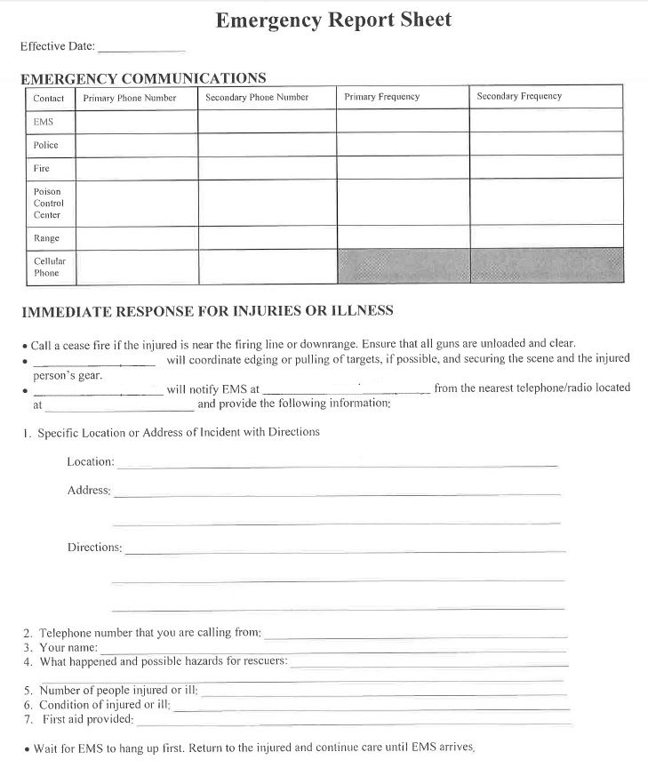
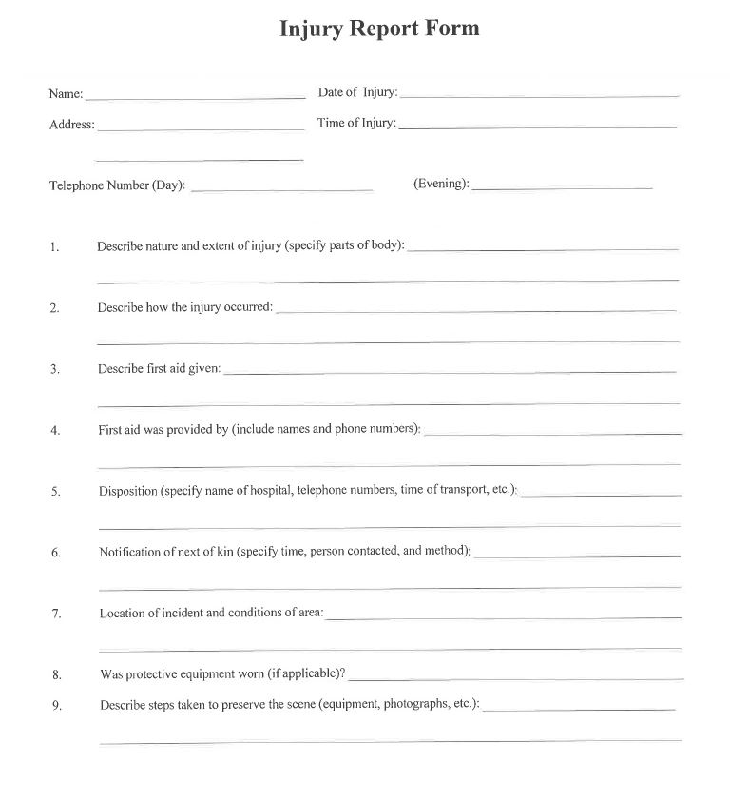
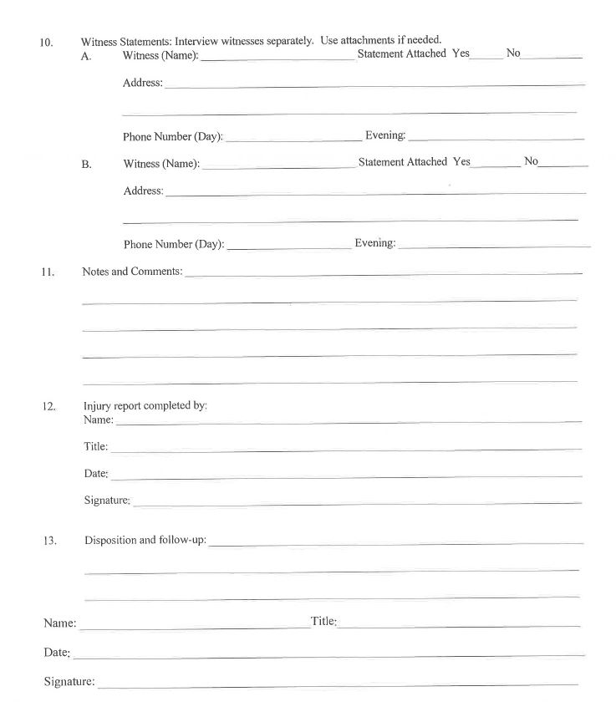

Release, Waiver, Indemnification, Hold Harmless and Assumption of Risk Agreement
WHERE AS, in consideration of being permitted to attend a course for instruction in firearms, for the instruction of firearms, for use on premises, and for other good and valuable consideration, the receipt and sufficiency of which is hereby acknowledged. The Undersigned agrees to the following:
Undersigned agrees to indemnity, hold harmless and defend Putnam Fish and Game Sportsman Club, any Official of the Putnam Fish and Game club, to include Executive Staff, Trustees, Range Safety Officer(s), (hereinafter referred to as ” Instructor”), from any and all fault, liabilities, costs, expenses, claims, demands or lawsuits arising out of, related to or connected with: Undersigned’s presence at and/or participants in the course of instruction; the discharge or firearms Undersigned; Undersigned’s presence on or use of the range, buildings, land and premises (“Premises”); and any and all acts or missions of the Undersigned.
Undersigned furthermore waives for himself/herself and for his/her executors, personal representatives, administrators, assignees, heirs and next of kin, any and all rights and claims for damages, losses, demands and any other actions whatsoever, which he/she may have or which may arise against Instructor (including but not limited to the death of Undersigned and/or any and all injuries, damages or illnesses suffered by Undersigned or Undersigned’s property), which may, in any way whatsoever, arise out of, be related to or be connected with; the course of instruction; the Premises, including any latent defect in the Premises; Undersigned’s presence on or of use of said Premises; Undersigned’s property (whether or not entrusted to Instructor); and, the discharge of firearms. Instructor shall not be liable for, and the Undersigned, on behalf of himself/herself and on behalf of his/her executors, personal representatives, administrators, assignees, heirs and next of kin, hereby expressly releases the Instructor from any and all such claims and liabilities.
Pg. 1 of 2
Undersigned hereby expressly assumes the risk of taking part in the course for instruction in firearms and taking part in the activities on the Premises, which include, but are not limited to instruction in the use of firearms, the discharge of firearms and the firing of live ammunition.
Undersigned hereby acknowledges and agrees that Undersigned has read this instrument and understands its terms and is executing this instrument voluntarily. Undersigned furthermore hereby acknowledges and agrees that he/she has read, understands and will at all times abide by all range rules and procedures and any other rules and procedures stated by the Instructor.
Undersigned expressly agrees that this instrument is intended to be as broad and inclusive as permitted by law, and that if any provision of this instrument is held invalid or otherwise unenforceable, the enforceability of the remaining provisions shall not be impaired thereby. No remedy conferred by any of the specific provisions of this instrument is intended to be exclusive of any other remedy, and each and every remedy shall be cumulative and shall be in addition to every other remedy now or hereafter existing at law or in equity or by statute or otherwise. The election of any one or more remedy hereunder by the Instructor shall not constitute any waiver of Instructor’s right to pursue other available remedies. This instrument binds Undersigned and his/her executors, personal representatives, administrators, assignees, heirs and next of kin.

Undersigned: Date:________
Signature: __________________ Print Name: ______________________

Pg. 2 of 2
Range Rules
General OUTDOOR RANGE SAFETY RULES
(Outdoor Rifle and Pistol Range)
Ensure “RANGE OPEN” sign has been checked before firing.
Outdoor range is closed when hall is rented.
- All firearms are always pointed in a safe direction and unloaded until ready to fire, finger off trigger until ready to shoot
- All firearms unloaded and actions open when not actually shooting or when anyone is downrange.
- No handling of firearms when anyone is downrange.
- All firearms to be unloaded when leaving the firing line.
- Daylight shooting only. No Shooting before noon on Sunday.
- All shooting to be done while on concrete pad of range house from BEHIND the RED firing line.
- Targets will be placed only in designated areas and that the placement of targets in other than specified locations could be cause for suspension of membership
- PAPER or Stationary Clay Targets only.
- One LOADED firearm per shooter.
- NO rapid fire – 5 seconds minimum between shots.
- Call for “Cease Fire” and activate “DOWN RANGE” safety light prior to crossing red safety line and going downrange. Safety light is to be activated (when going downrange) even if you are the only person on the range
- Members are responsible for their guests. Rules apply to ALL shooters.
- Any member that observes any other member, or guest of a member, that creates an unsafe condition either for him / herself, other members, the facility or that could in any way impact the community or neighborhood surrounding the club, is obligated to either discuss the matter with the person or call the Range Chairman.
- Clean up your mess. This includes all destroyed targets (clays included), spent casings, etc. Put casings in appropriate buckets if you are not taking them with you.
- “Duds” are placed in appropriate repositories. DO NOT throw them in the trash.
Parents and Junior Shooters
- Junior shooters that are 8 years old and younger are to be supervised, “one on one” by an adult (minimum 18 years old).
- Junior shooters ages 9 through 11 years old are to be supervised maximum 2 juniors to one adult. (Exception: junior has successfully passed DEEP firearms safety course)
- Junior shooters (up to 11 years old) not actually on the firing line shooting or preparing to shoot, will wait in the safe area and remain seated until it is their turn to shoot.
- Running or horse play in the range area will not be tolerated. Distractions to other shooters using the range can cause serious harm and have dangerous consequences.

By signing your name below, you are in agreement to follow the above rules and any other rules that were reviewed with you, without exception. Parent or guardian must sign for shooters under 18 years of age (minor).
Pg. 1 of 2
Signed: ____________________________________ Date: __________
Print Name: ________________________________
Print Name of minor: _________________________ ____

Pg. 2 of 2
Range Rules
Indoor Range,
Pistol & Rifle (club events)
- All firearms are always pointed in a safe direction and unloaded until ready to fire, finger off trigger until ready to shoot
- All firearms unloaded and actions open when not actually shooting or when anyone is downrange.
- No handling of firearms when anyone is downrange.
- All firearms to be unloaded when leaving the firing line.
- Doors of the indoor range shall be kept closed while firing events are underway.
- All shooting to be done while from BEHIND the firing line.
- Shoot toward designated targets on target holders only – PAPER or Stationary Clay Targets only.
- One LOADED firearm per shooter.
- Call for “Cease Fire” and activate “DOWN RANGE” safety light prior to crossing red safety line and going downrange. Safety light is to be activated (when going downrange) even if you are the only person on the range
Pg. 1 of 1
- Members are responsible for their guests. Rules apply to ALL shooters.
- Any member that observes any other member, or guest of a member, that creates an unsafe condition either for him / herself, other members, the facility or that could in any way impact the community or neighborhood surrounding the club, is obligated to bring the matter to the RSO.
- Clean up your mess. This includes all destroyed targets (clays included), spent casings, etc. Put casings in appropriate buckets if you are not taking them with you.
- “Duds” are placed in appropriate repositories. DO NOT throw them in the trash.
Parents and Junior Shooters
- Junior shooters that are 8 years old and younger are to be supervised, “one on one” by an adult (minimum 18 years old).
- Junior shooters ages 9 through 11 years old are to be supervised maximum 2 juniors to one adult. (Exception: junior has successfully passed DEEP firearms safety course)
- Junior shooters (up to 11 years old) not actually on the firing line shooting or preparing to shoot, will wait in the safe area and remain seated until it is their turn to shoot.
- Running or horse play in the range area will not be tolerated. Distractions to other shooters using the range can cause serious harm and have dangerous consequences.
By signing your name below, you are in agreement to follow the above rules and any other rules that were reviewed with you, without exception. Parent or guardian must sign for shooters under 18 years of age (minor).
Signed: ____________________________________ Date: __________
Print Name: ________________________________
Print Name of minor: _________________________ ____
Acronyms
CMP – Civilian Marksmanship Program
CRSO – Chief Range Safety Officer
DEEP – Department of Emergency and Environmental Protection
IAW – In Accordance With
NRA – National Rifle Association
RSO – Range Safety Officer

